Design Updates
URL:
http://us15.campaign-archive2.com/?u=12a794b2402eb103cba5c25f4&id=f56d4f3654
- Post my Flight Button - Button needs to be moved further left (see red line)
Currently:

- Change Background (please remove lower copy and remove design of sign up box) – see red lines


- Change the Design of the Lower section
- remove fill out box (red lines)
- Add Content “Airnugget is the new and easy way to make money
searching for flights on your own schedule” (Colour Grey same as below)
- Add Sign Up Button (link to homepage
Currently:
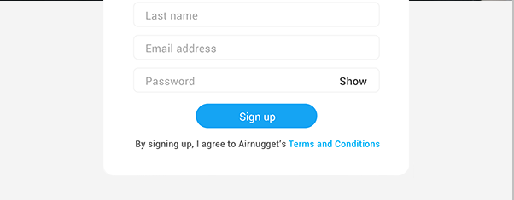
Update:
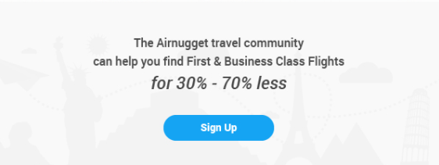
Airnugget is the new and easy way to make money
searching for flights on your own schedule!
- Please use correct background image not grey background
Currently:
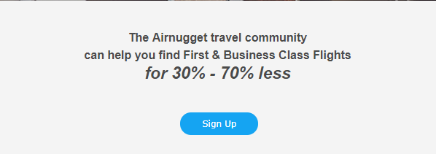
Update: (background image has famous buildings)
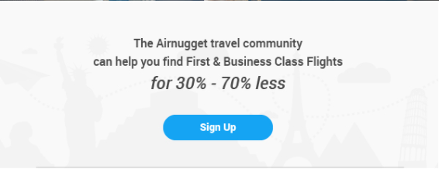
- Please move Sign Up button further up (see red arrow)
Currently:
Update:
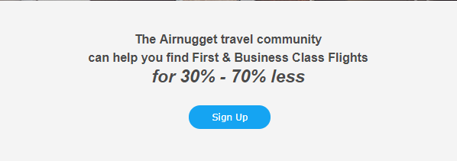
- Button Link URL – Please update as below

https://plus.google.com/116469662694192725459/about
- Logo Link – Add link to Logo

https://airnugget.com/

